### Identity Tokens

Identity Tokens to access the Together1 API for testing purposes (e.g. using Postman) can be obtained by authenticating to Together1 using the browser and grabbing the ID Token from the debugging output of the Credential Service (filter the console for the string ‘[CredentialsService]’:

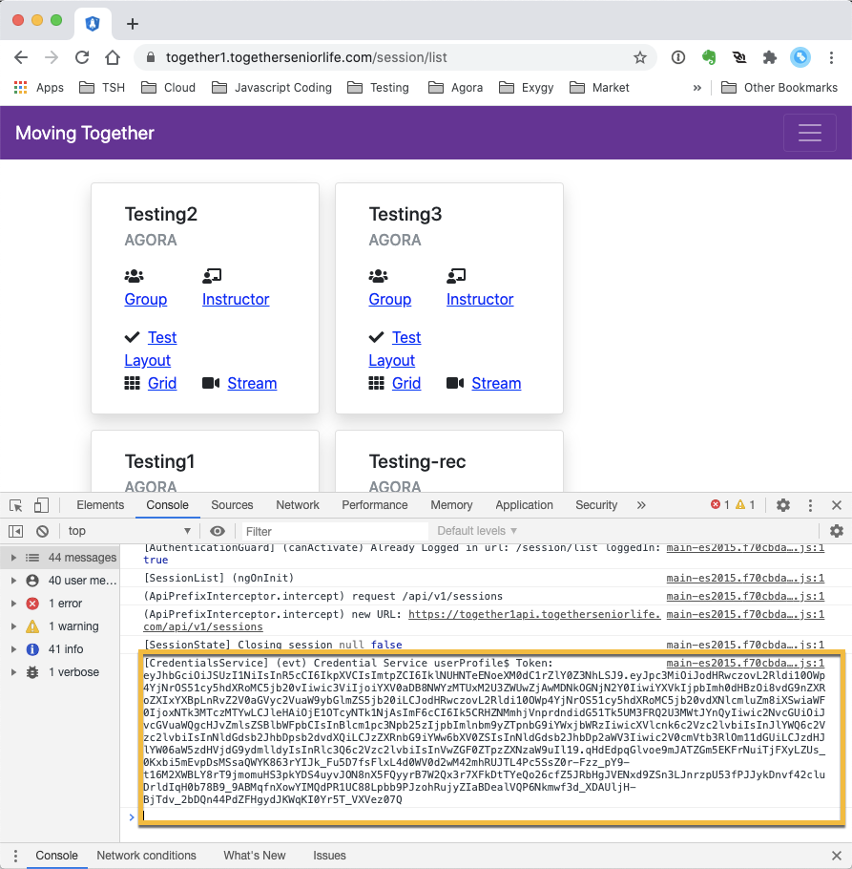

Note that Identity Tokens include the identity and grants of a Together1 user, whereas access tokens do not.

(continued)

### Postman Authentication Using Tokens

In Postman, you can set this as a Bearer token for the authentication:

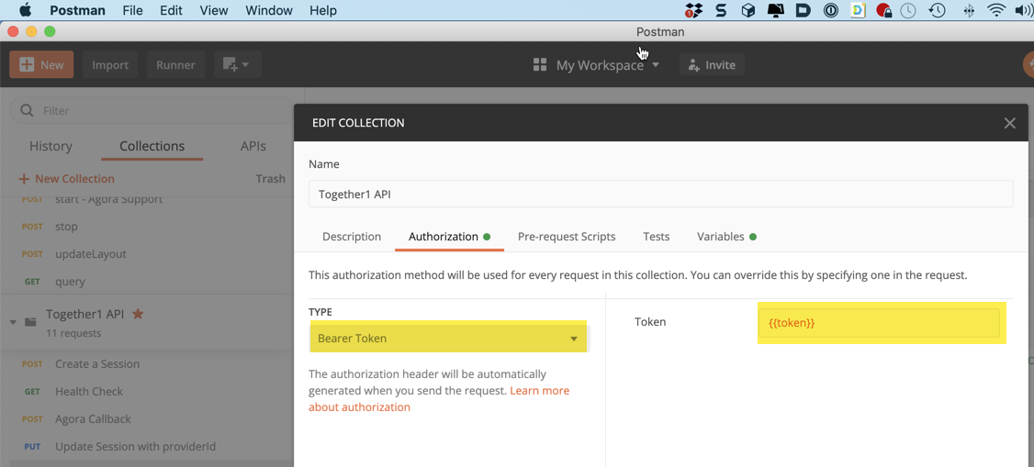

(continued)

### Access Tokens from Auth0 Dashboard

Access Tokens to access the Together1 API can be generated using the Auth0 dashboard.

Go to “APIs/Together1API”:

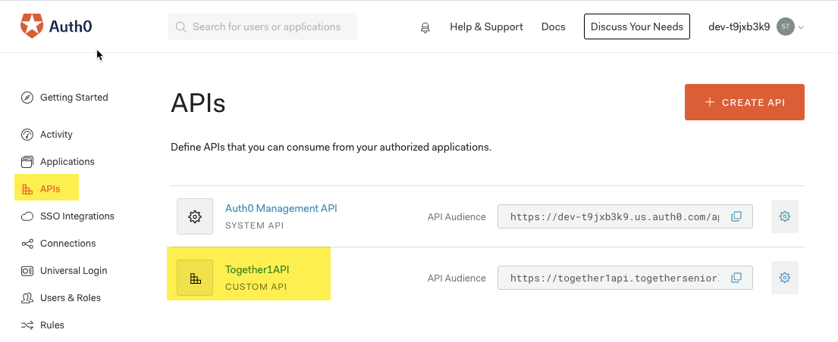

(continued)

Then in the API, open the “Test” tab:

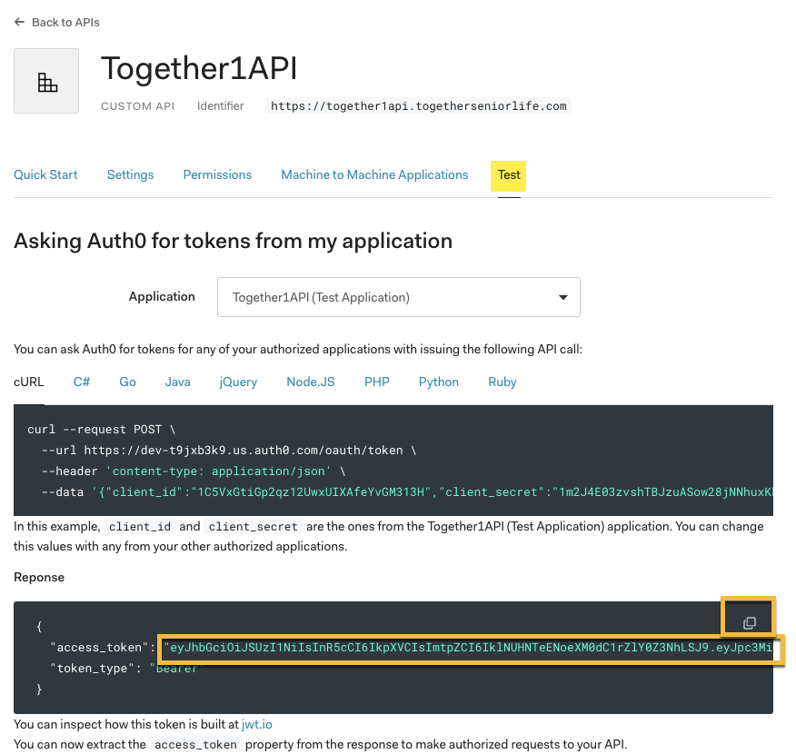

You can use the token in the example response, highlighted above.

To see the contents of the token, the site <http://jwt.io> can decode the token for you. For example:

| {  header: {  "alg": "RS256",  "typ": "JWT",  "kid": "IMPsSxChys4t-kfV4gsa-" } payload: {  "iss": "https://dev-t9jxb3k9.us.auth0.com/",  "sub": "1C5VxGtiGp2qz12UwxUIXAfeYvGM313H@clients",  "aud": "https://together1api.togetherseniorlife.com",  "iat": 1597167538,  "exp": 1597253938,  "azp": "1C5VxGtiGp2qz12UwxUIXAfeYvGM313H",  "gty": "client-credentials",  "permissions": [] } } |
| --- |
| Notice that the token will authenticate to the API, but it does not contain an Auth0 identity (‘sub’ property of the payload) and no permissions, so it may not be useful for some scenarios. |